Task 1: Process Synchronization and Child Process Monitoring Using waitpid()

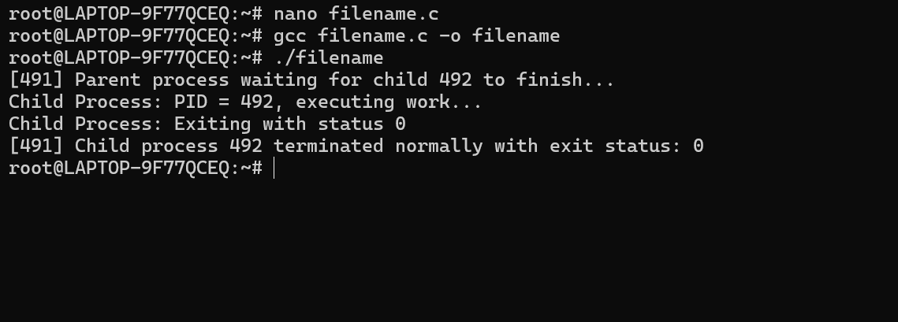

Task 2: To Retrieve PATH Variable, Parse Search Directories, Locate Executables, Verify Permissions, Handle Missing Commands, Test Command Resolution
Function | Purpose
getenv() | Retrieves the PATH environment variable
strtok() | Splits PATH into individual directories
access() | Checks file existence and execute permission
snprintf() | Builds the complete executable path
strdup() | Creates a modifiable copy of PATH
free() | Releases allocated memory
Flow Chart:
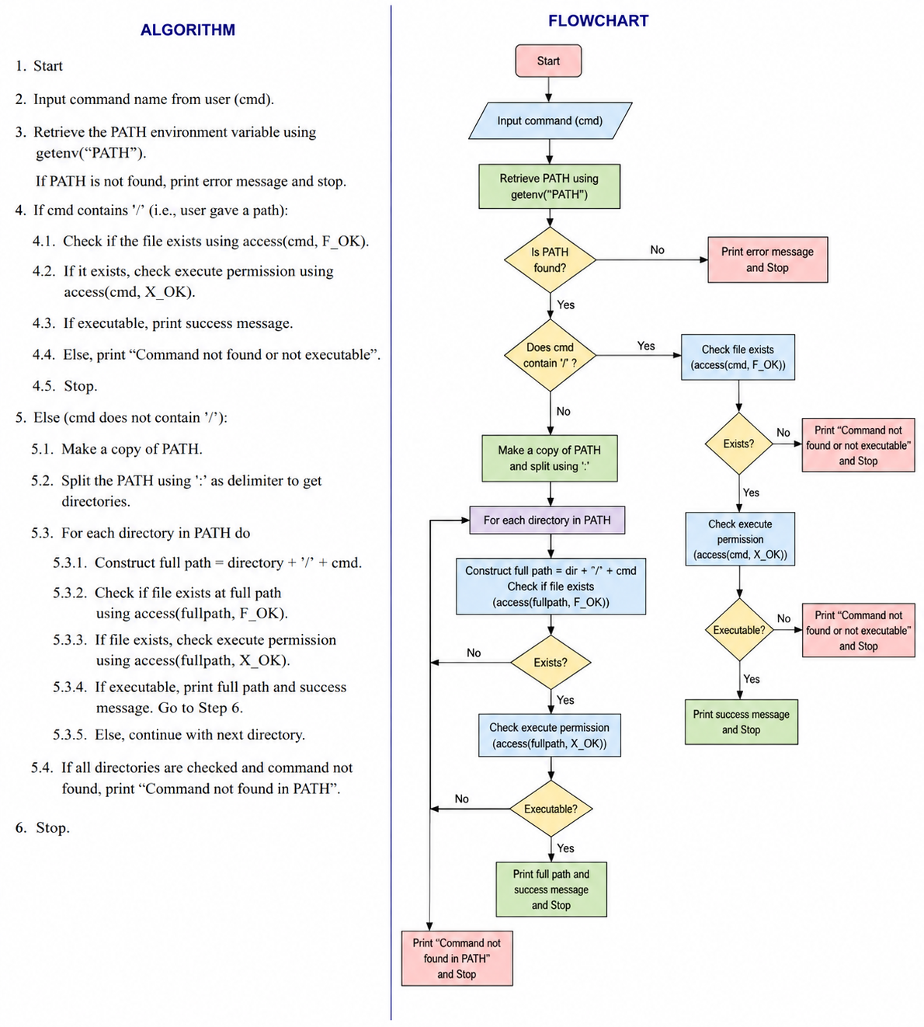
Sample Output:
Case 1:
./T2 pwd
PATH = /usr/local/sbin:/usr/local/bin:/usr/sbin:/usr/bin:/sbin:/bin:/usr/games:/usr/local/games:/mnt/c/Program Files/WindowsApps/CanonicalGroupLimited.Ubuntu_2404.1.68.0_x64__79rhkp1fndgsc:/mnt/c/Windows/system32:/mnt/c/Windows:/mnt/c/Windows/System32/Wbem:/mnt/c/Windows/System32/WindowsPowerShell/v1.0/:/mnt/c/Windows/System32/OpenSSH/:/mnt/c/Program Files/Microsoft VS Code/bin:/mnt/c/Users/DELL/AppData/Local/Microsoft/WindowsApps:/mnt/c/Users/DELL/AppData/Local/GitHubDesktop/bin:/snap/bin

File found: /usr/bin/pwd
Execute permission: YES
Command resolved successfully.

Case 2:
./T2 Raghu
PATH = /usr/local/sbin:/usr/local/bin:/usr/sbin:/usr/bin:/sbin:/bin:/usr/games:/usr/local/games:/mnt/c/Program Files/WindowsApps/CanonicalGroupLimited.Ubuntu_2404.1.68.0_x64__79rhkp1fndgsc:/mnt/c/Windows/system32:/mnt/c/Windows:/mnt/c/Windows/System32/Wbem:/mnt/c/Windows/System32/WindowsPowerShell/v1.0/:/mnt/c/Windows/System32/OpenSSH/:/mnt/c/Program Files/Microsoft VS Code/bin:/mnt/c/Users/DELL/AppData/Local/Microsoft/WindowsApps:/mnt/c/Users/DELL/AppData/Local/GitHubDesktop/bin:/snap/bin

Command 'Raghu' not found in PATH.

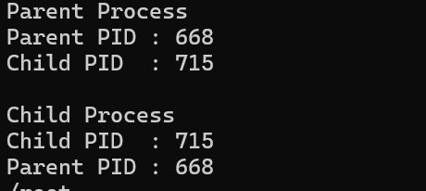

Task 3: To Detect Variable References, Expand Values, Handle Undefined Variables, Update Tokens, Support Nested Variables, Test Expansion Logic.

Function | Purpose
getenv() | Retrieves environment-variable values
fgets() | Reads input
strcspn() | Removes newline
isalpha() | Checks alphabetic character
isalnum() | Checks alphanumeric character

Flow Chart:
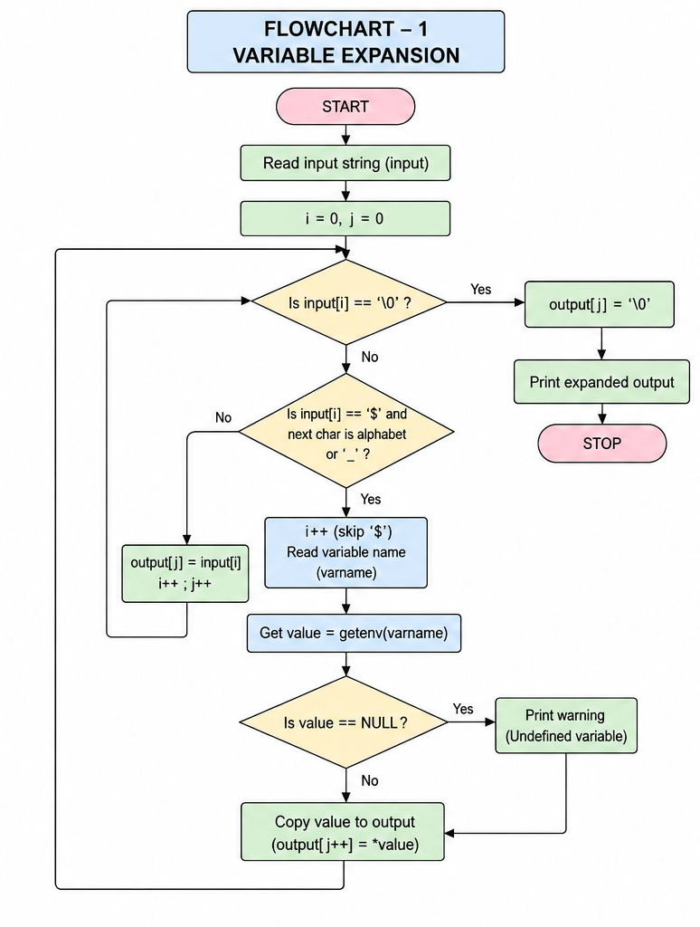

Sample Output:
Case 1:
Enter a string: Raghu
Original : Raghu
Expanded : Raghu

Case 2:
Enter a string: hello $abc
Warning: Undefined variable: abc
Original : hello $abc
Expanded : hello

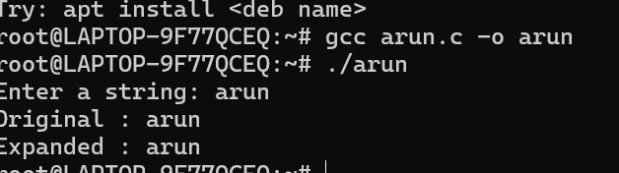

Task 4: To Identify Built-ins, Create Dispatch Table, Execute In-Process Built-ins, Handle Invalid Commands, Maintain State, Test Dispatch Logic
Function | Purpose
chdir() | Changes the current working directory
getcwd() | Gets the current working directory
getenv() | Retrieves environment variables
exit() | Terminates the process
strcmp() | Compares command names
strtok() | Separates command into tokens

Flow Chart:
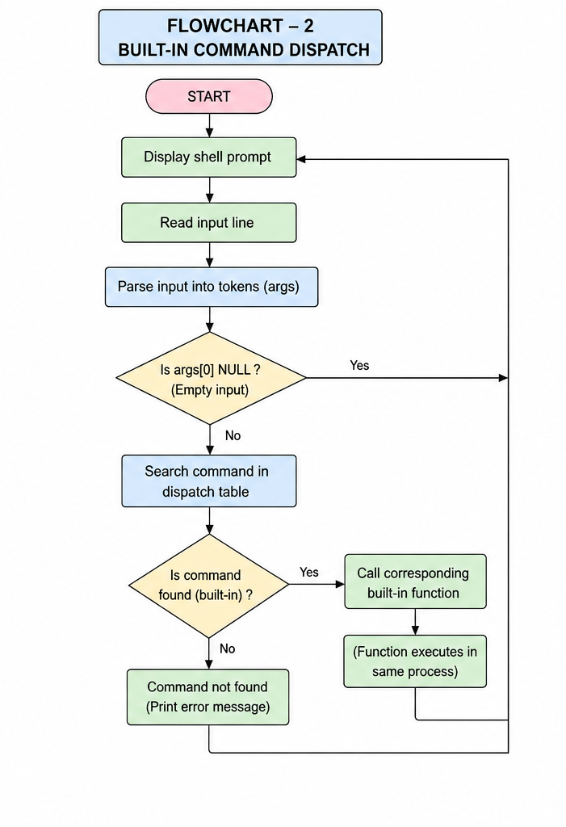

Sample output:
myshell> pwd
/home/student

myshell> echo Hello World
Hello World

myshell> cd /tmp

myshell> pwd
/tmp

myshell> abc
Command not found: abc

myshell> exit
Exiting shell...
